Economic Consequences of the COVID-19 Eruption: A study of Selected South Asian Countries
Neelam Hafeez
Department of Economics
The University of Lahore
Emial: neelamhafeez2@gmail.com
Sadia Naseem Naik
Department of Economics
The University of Lahore
Emial: anoshaysadiqe@gmail.com

Abstract
The Covid-19contagion has truly prompted human emergencies and economic tremors. It has also created a significant threat for the whole world exposing lack of preparedness for such large scale spread of epidemic. It has created various economic risks specifically in financial markets of the developing countries of South Asia. Significant and abrupt reduction in economic activities and economic development of the developing and developed economies has posed a serious challenge for the future. This pandemic situation has reduced productivity, employment, transportation of goods and services and trade. The reason behind the disruption is underestimation of the rapid spread of this pandemic and its economic consequences in the economies. Adversely, there is no indication that this situation is improving in the near future. It is essential to adopt strategies to not only combat this situation but if it persists longer than expected, then how to live with it.
- Introduction
Covid-19 blowout almost all over the globalized world has struck worldwide fear and it has disastrous consequences on human lives as well as financial health of the world including South Asian economies (Pakistan, India, Bangladesh, Nepal and Sri Lanka).Currently the scholars have great interest in these outliers for the preparedness of such consequences. The World Health Organization declared Covid-19 a world health emergency first time in January 2020. It was initially diagnosed in Wuhan in China. On May 23, 2021, the World Health Organization (WHO) considered COVID-19 as a contagion, indicating over167408431 total confirmed cases,347796 deaths and 148441532 recovered cases in the world. Covid-19 also destabilized all economic behaviors and financial markets by reducing productivity, tourism, trade, transport and manufacturing. This alarming condition is a wakeup call for political leaders and policy makers to deal with the epidemic aftermaths.(Adegboye, 2020)(Albulescu, C. T. et al. (2021).
UNICEF, 2020 reported that IMF had predicted world economy will shrivel and national economies have been cruelly hit across the south Asian countries forecast to experienced severe depressions. These exceptional risks required unprecedented measures. Since most of the people of regions survived on low and insecure income. Income has slashed causing losses of jobs and reduction in remittances creating downward fluctuations in financial markets. Unfortunately, most of the south Asian countries have poor social protection system only Nepal and Maldives have modern social protected system. The COVID-19 global epidemic has had a notable effect on the worldwide economy. To mitigate the damage caused by this unexpected crisis, the total cost of the global bailout has been estimated at not less than USD 5 trillion, started injecting as a cash flow boost.( Ghouse, G.2021).
There is a query as to whether this disaster will have a permanent structural influence on the international economy, or these are only for largely temporary financial and economic magnitudes. The financial instability affected by different economic condition, weak institutional structure and market imperfections (Hartwell, 2018). Due to the investment connections with US economy the effect of financial crisis has been transfer into Pakistan (Ghouse, G, 2019). Macroeconomic policies also affect the financial capriciousness. Onan et al. (2014) find that good and bad announcements asymmetrically impact the financial volatility, whereas most of recent studies focus on the role of Economic Policy Uncertainty (EPU) in influencing the financial volatility (Antonakakis et al., 2013; Chen and Chiang, 2020; Kalyvas et al.,2019; Li et al., 2020; Mei et al., 2018; Su et al., 2019; Tiwari et al., 2019 Karnizova and Li (2014) predicted that US recession using the interaction between EPU index and stock market volatility. This index used for forecasting the outlier of stock market for future policy making. The role of Governments of the worldwide economies necessary for preparedness of the substantial influences of covid-19 on stock markets (Zeremba et al 2020). numerous studies on attaining sustainable growth, many countries keep suffering into massive inequality , higher poverty, and wide unemployment , that aren't measured while only economic growth measures such as GDP are considered (Ghouse et al., 2022).
Although abrupt action has initiated in the US and European countries but many low and middle-income countries like South Asian countries are still waiting for funding from finance authorities like International Monetary Fund (IMF), World Bank (WB) and Asian Development Bank (ADB) support to deal with the pandemic (Islam et al,2020). The data on the spread of the coronavirus were collected from the World meter (worldometer.com). Firstly, reported confirmed cases of the novel coronavirus (COVID-19), now exceed 9.7 million in the selected South Asian countries as of 23May 2021 and are likely to increase.
Table 1.Total COVID-19 cases in South Asian countries up to 23 May 2021.
Country | Total Cases | Deaths | Recovered
Bangladesh (BD) | 789,080 | 12,376 | 730,697
India (IND) | 26,738,220 | 303,355 | 23,693,992
Sri Lanka (SL) | 161,242 | 1,178 | 128,607
Nepal (NEP) | 513,241 | 6,346 | 391, 348
Bhutan (BHU) | 1,394 | 1 | 1,186
Pakistan (PAK) | 900,552 | 20,251 | 817,681
Maldives (MAL) | 55,924 | 129 | 32,322
Afghanistan (AFG) | 66,275 | 2,812 | 56.035
Note: There may be unconfirmed cases that were never reported to the public health authorities.
The table shows that only one death due to COVID-19 in Bhutan and minimum cases of COVID-19 in Bhutan. Maldives is on second number in lowest cases. India has largest rate of death and total cases of COVID-19 and Pakistan is second largest number in COVID cases in the South Asian countries. It spreads at global level due to global interactions. While it harms old people who have health issues, it also affects the young.
Thus, unexpected eruption in heavily populated South Asian countries due to the incorrect perception from media and then delayed protection and quarantine measures adopted by the governments. Improper social distancing started second wave of pandemic, which triggered a rapid expansion and eventually affected economic activity. The gravity of the first time and later on the great depression, all the economies are facing health crises as well as economic recession. It also impacts FDI and remittance amount, which worsens the growth effects and GDP level (Ahmad, M 2020). Developed countries are trying to combat with these shocks by investing on new technology to control this pandemic. Even though, developed economies and developing economies are still suffering from this recession in 2021. The South Asian countries are still trying to halt the spread of these consequences.
- Literature review
Albulescu, C. T. (2021) empirically examined the impact of COVID-19 new infectious and fatality cases on the financial market of United States. The daily data has been used for estimation that comes from WHO situation reports (COVID-19 statistics) and S&P Dow Jones Indices database, correspondingly (RVdata). The S&P 500 of 3-months comprehended volatility index used as a proxy for the US financial markets’ instability. Ordinary Least Squares (OLS) regression applied to investigate the new coronavirus influence on the financial impulsiveness. It concludes that COVID-19 has a positive and a momentous impact on the financial capriciousness. There were outliers in data of covid-19 and results of OLS affected by these outliers. Subsequently the RLS approach applied for M-estimation (Huber, 1973). All these estimations also confirmed by the early findings in the literature about the effect of COVID-19 on the financial volatility (e.g., Albulescu, 2020; Zarembaetal.,2020). Adegboye, (2020) observed the impact of widespread covid-19 on financial market of developed countries. It concludes that the virus is expected to carry on disturbing economic actions and destructively affects manufacturing and service industries, particularly in developed countries. The financial markets will further be impulsive in the near future. Whereas the literature explored specific regions of developed world and developing countries kept ignored. Zhu et al. (2019) examine the impacts of fear index on the US stock market instability. Zaremba et al. (2020) explored the effect of COVID-19 on the stock market volatility in the global world and how governmental intervention affects this situation. While Bakas and Triantafyllou (2020) examined the influence of the worldwide epidemic on commodity prices’ instability. The prices are not stable as the epidemic covid-19 exacerbates the economic state of affairs. However, the literature didn’t examine the impact of covid-19 on overall financial market performance. Mei et al, (2018) pondered the importance of economic policy uncertainty index for forecasting of US financial market outliers. Whether it is useful to gain predictive information for forecasting European stock market. The out-of-sample R² test used for analysis and it reveals that EPU index is not very helpful to predict European stock market outliers for policy making. While using the US EPU index for the benchmark model provide accurate results during recessions. Hence the findings are ambiguous, and policies not described in the study. Karzinove, (2014) used probit recession forecasting model to evaluate the capability of EPU that is developed by Baker et al, (2013) to predict recession in US stock market. Financial variables like interest rate spread, stock market instability and stock returns used in this analysis. The index is based on newspapers reports. It concludes that EPU is economically significant for forecasting the volatility of the markets. G. Ghouse, N. Ejaz, M.I. Bhatti et al , (2022) The 2008/2009 worldwide financial crisis was one of the most devastating economic collapses since World War II, and it severely harmed the conventional and Islamic banking in OIC countries.
Islam et al, (2020) analyzed potential economic impact of COVID-19 in south Asian countries by using an organized evaluation method. The cause-effect association framework showed that the eruption of COVID-19 decreased the gross domestic product (GDP) and other major economic sectors and indicators in the South Asian economies. The short and long-run predicted scenario showed in the study. It concludes that to cope with this scenario government of the economies play an important role to formulate appropriate policies and programs. The emerging challenges on the environmental costs of greater growth in real output from utilisation of energy, rapidly changing patterns of energy production and consumption, globalization, the COVID-19 pandemic, an absence of economic sustainability assistance, renewable energy technologies, and human capital demands among other factors. Bhatti, M. I(2022)
The literature has well documented numerous consequences of COVID-19 in different regions. Here is still a gap that no study explores the impact of COVID-19 on financial market in South Asian countries. Therefore, the present paper contributes to the literature and designs to fill the gap. In this study I have analyzed the impact of COVID-19 financial markets of South Asian countries.
In India, the pandemic has resulted in a decline in GDP growth, with the International Monetary Fund (IMF) forecasting a contraction of 10.3% in 2020. The lockdown measures implemented to control the spread of the virus have disrupted supply chains and led to a decline in consumer demand, leading to a decline in economic activity. The service sector, which accounts for a significant share of the economy, has been particularly hard hit.
In Bangladesh, the pandemic has also had a negative impact on the economy, with the IMF forecasting a decline in GDP growth of 3.8% in 2020. The country's export-oriented manufacturing sector, which accounts for a large share of GDP, has been adversely affected by the decline in global demand. In addition, the pandemic has disrupted supply chains and led to a decline in remittances, which are a major source of foreign exchange for the country.
In Pakistan, the pandemic has had a mixed impact on the economy. While some sectors, such as agriculture and remittances, have been relatively resilient, others, such as manufacturing and services, have been negatively affected. The IMF forecasts a decline in GDP growth of 1.5% in 2020.According to the State Bank of Pakistan, debt was worth Rs. 34.24 trillion in September 2019, accounting for 79% of GDP G. Ghouse,et.al (2020)
In Nepal, the pandemic has had a severe impact on the economy, with the IMF forecasting a decline in GDP growth of 7.5% in 2020. The country's reliance on tourism and remittances, which have both been negatively affected by the pandemic, has exacerbated the economic impact.
Overall, the economic consequences of the COVID-19 pandemic have been significant for South Asian countries. The decline in GDP growth and disruptions to supply chains and other economic activities have had negative impacts on the economies of these countries.
One of the main impacts has been a decline in loan demand as businesses and individuals have faced economic hardship and uncertainty due to the pandemic. This has led to a decrease in net interest margins, as banks have been unable to lend as much as they normally would.
The pandemic has also led to an increase in credit risk as businesses and individuals struggle to make loan payments. This has resulted in an increase in nonperforming loans and provisions for loan losses, which have weighed on the profitability of banks.
In addition to the impacts of the pandemic, political and financial events can also affect the performance of the commercial banking sector. For example, regulatory changes and government policies can impact the operating environment for banks, while market movements and economic conditions can affect the demand for financial products and services.
Overall, the performance of the commercial banking sector has been negatively affected by the COVID-19 pandemic, as well as by a range of political and financial events. The impact of these events on the sector will depend on the specific circumstances and the individual bank's ability to adapt and respond.
One study using wave analysis found that the impact of the pandemic on the Islamic finance industry varied depending on the stage of the pandemic. In the early stages, the industry was affected by supply-side disruptions as lockdowns and other measures disrupted the operation of financial institutions. This led to a decline in the volume of Islamic finance transactions.
In the later stages of the pandemic, the impact on the Islamic finance industry became more demand-driven as economic downturn and uncertainty led to a decline in the demand for financing. This has had negative impacts on the profitability and growth of Islamic financial institutions.
Other studies have found similar asymmetric effects of the pandemic on the Islamic finance industry. For example, one study found that the pandemic had a greater impact on Islamic banks compared to conventional banks, with Islamic banks experiencing a decline in profitability and liquidity.
Overall, the COVID-19 pandemic has had asymmetric spillover effects on the performance of the Islamic finance industry, with the impact varying depending on the stage of the pandemic and the specific characteristics of the institutions. Further research using wave analysis and forecasting techniques could help to better understand and predict the impacts of future events on the Islamic finance industry.
- Number of daily COVID cases and daily deaths in South Asia
The Coalition for Epidemic Preparedness Innovations (CEPI), a global partnership has tracked global efforts in COVID-19 vaccine development activity and is advocating for strong international cooperation to ensure that vaccine, when developed, will be manufactured in sufficient quantities and that equitable access will be provided to all nations regardless of ability to pay. Higher management must confirm that the organizational environment encourages and improves creativity at an individual level. Rizwan, K. ul R (2021), Qamar, A (2021) The trend of decreasing public development spending may have a variety of effects on GDP growth. Reduced public spending on education, social services, and healthcare has an impact on human capital, which is viewed as a necessary condition for economic growth as well as the long-term viability of the economy. . Human capital developments can create a virtuous circle, allowing for technological adaptation and progress in the developing world (Aslam, A. 2023).
Furthermore, affected countries may benefit from exchanging technological innovations in contact tracing, such as health Quick Response (QR) codes, to manage the outbreak more effectively. Aslam, A (2021) highly technologically advanced goods and complex manufacturing structures necessitate a high level of technical understanding, concentration, and advances in technology. However, Figures below from a to g showed cumulative number of confirmed cases in South Asian Countries and number of daily deaths. Data for these graphs was extracted from WHO Coronavirus live update.
Figures presented below depicts the dynamics of confirmed COVID- 19 cases and shows in South Asian countries, e.g., a) Afghanistan, b) Bangladesh, c) India, d) Pakistan, e) Nepal, f) Maldives, and g) Sri Lanka. The South Asia have already outnumbered China, the origin of epidemic, in the number of confirmed COVID-19 cases and number of deaths.

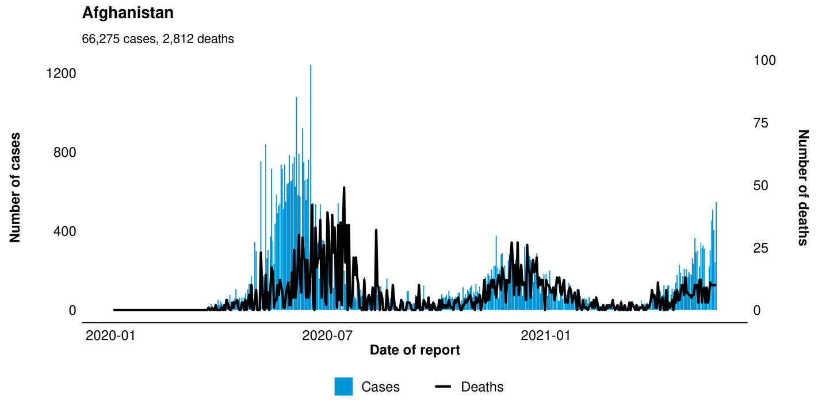

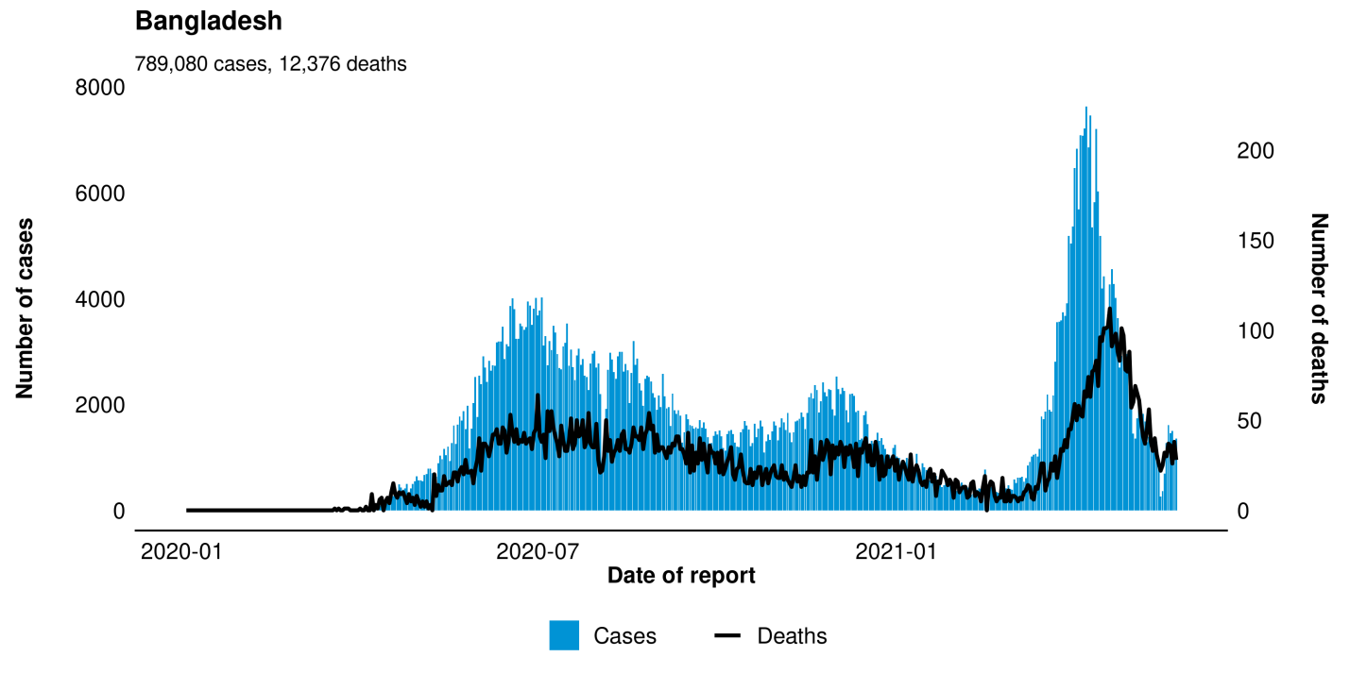

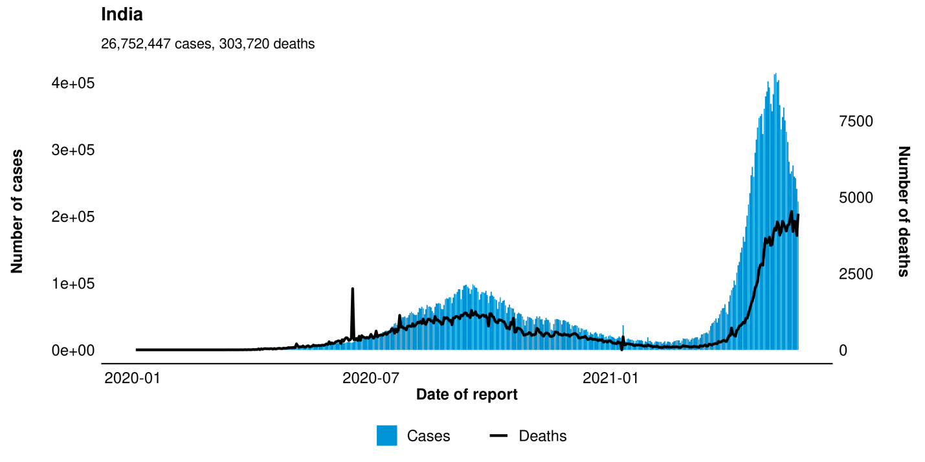

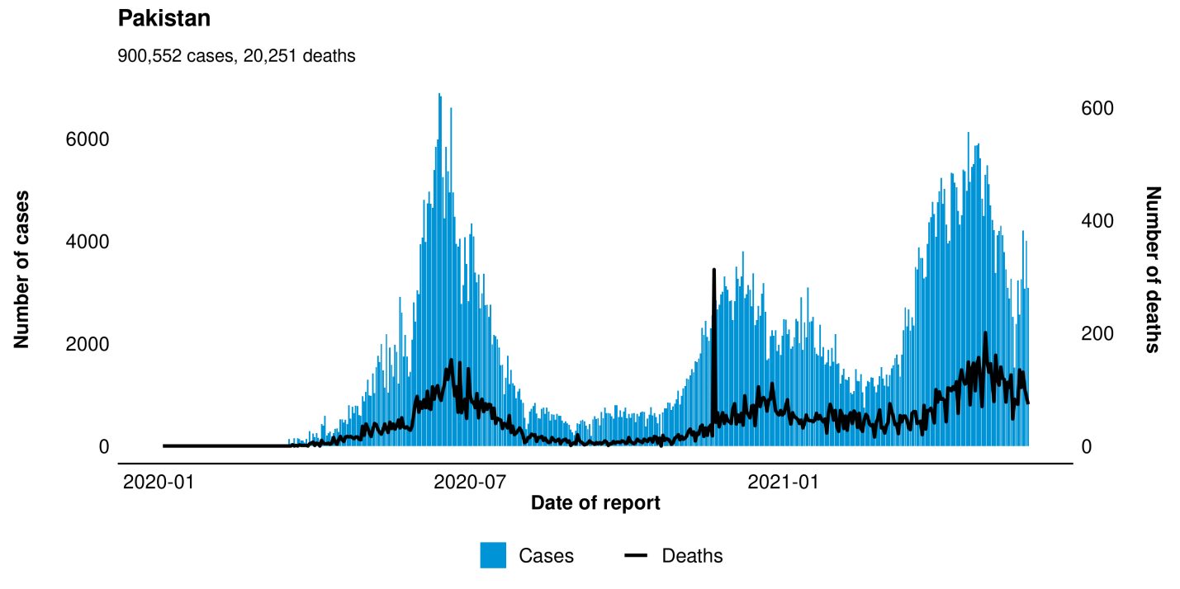

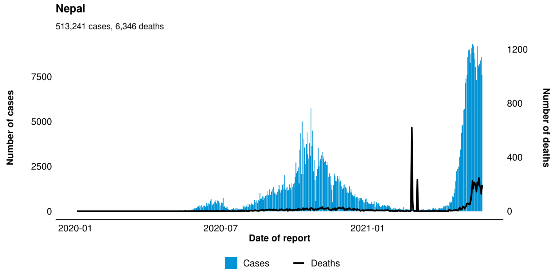

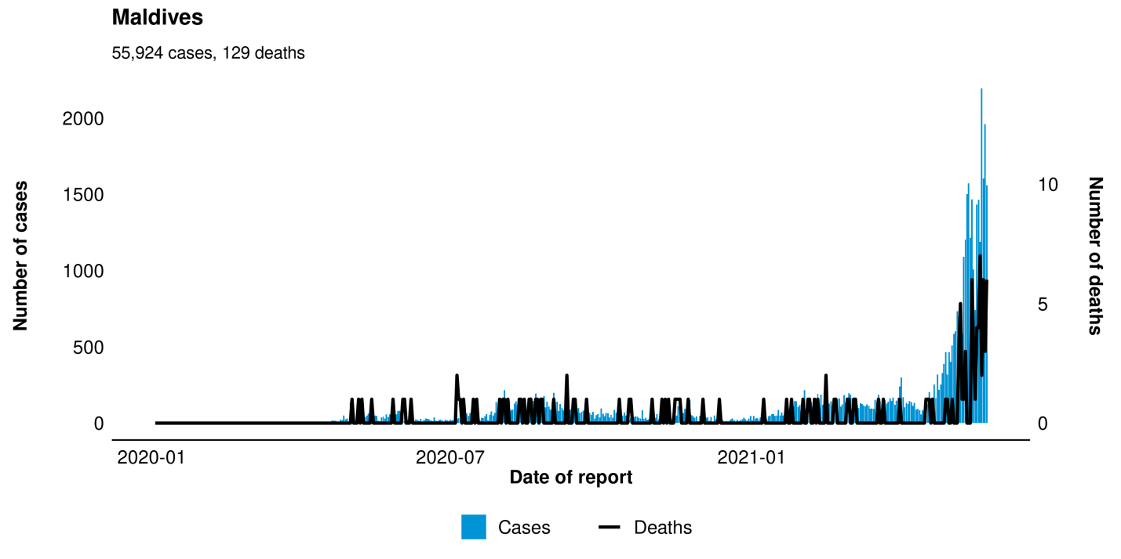

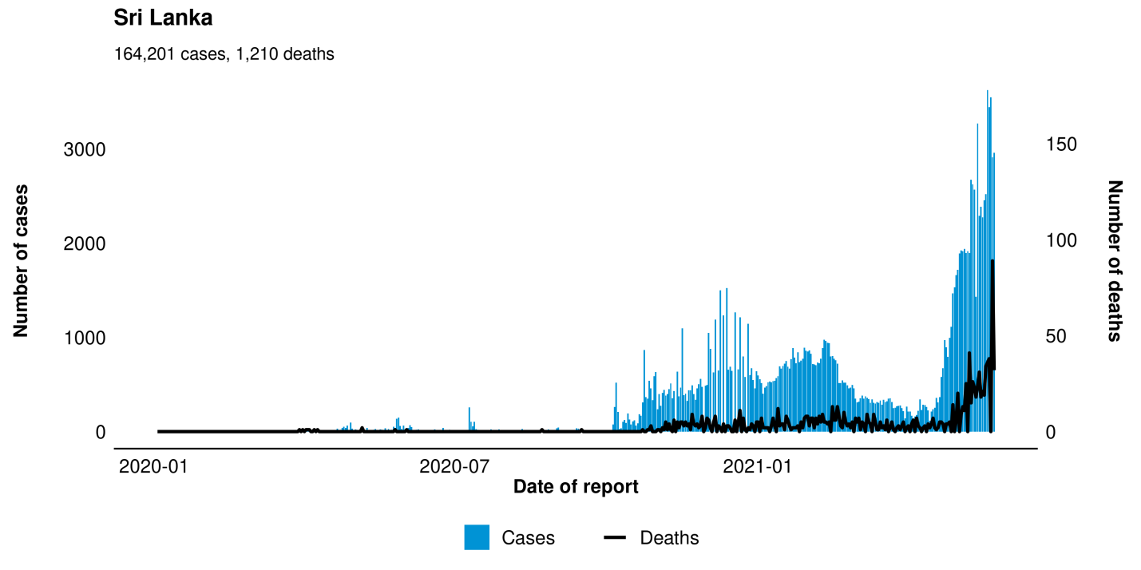
Dynamics of the value of stock indices of major South Asian Stock Markets relative to February 2020 was shown in Figure 1. Data used in this trend analysis was extracted separately from the respective Stock Markets website. Closing prices of the Market were used in the calculations. Daily values were calculated relative to an index value (100) on February 2, 2020. there are important privacy implications that need to be considered. In the case of COVID-19, the collective response and adoption of preventive measures to stop the global spread were implemented too late, after COVID-19 had already penetrated other regions through international travel.

Figure 1: Daily change in Stock prices relative to the February 2020 in Major Stock Markets of South Asia
Global financial markets have been heavily impacted by the effects of COVID-19 spread. As the numbers of cases started to increase globally, mainly through the US, Italy, Spain, Germany, France, Iran, and South Korea, the world financial and oil markets significantly declined. The figure 2 showed the correlation between the major stock markets of South Asian countries and the daily increase in number of COVID patients. The Greenish side of the cells showed a positive correlation and the yellow to red side with negative correlation. It is evident from the Figure 2 that most of the stock exchanges have a high correlation with the number of positive COVID patients. The Colombo Stock Exchange of Sri Lanka has a slighter less correlation. It shows how this pandemic effected the global and regional market and business across the globe.
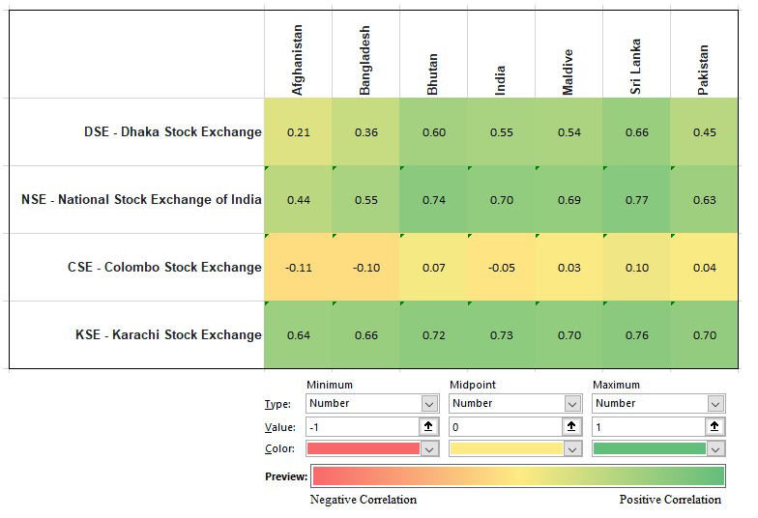
Figure 2: Correlation between number of COVID cases and Major Stock Market in South Asia
The negative correlation shows by red color and highest negative value is -0.11. While positive correlation shows by green color and highest positive value is 0.77 in (figure 2).
- Concluding Remarks
As the spread of the Coronavirus is likely to continue disrupting economic activity and negatively impact manufacturing and service industries, especially in developing countries, we expect that financial markets will continue to be volatile. There is still a question as to whether this expanding crisis will have a lasting structural impact on the global economy or largely short-term financial and economic consequences. In either case, it is evident that infectious diseases such as COVID-19 have the potential to perpetrate severe economic and financial costs on regional and global economies. Because of high transportation connectivity, globalization, and economic interconnectedness, it has been extremely difficult and costly to contain the virus and mitigate the importation risks once the disease started to spread in multiple locations. This warrants international collective action and global investment in vaccine development and distribution, as well as preventive measures including capacity building in real-time surveillance and the development of contact tracing capabilities at the national and international levels. As outbreaks of novel infections are not likely to disappear in the near future, proactive international actions are required not only to save lives but also to protect economic prosperity.

References
Albulescu, C. T. (2021). COVID-19 and the United States financial markets’ volatility. Finance Research Letters, 38, 101699.
Andersen, T. G., Bollerslev, T., Diebold, F. X., &Labys, P. (2003). Modeling and forecasting realized volatility. Econometrica, 71(2), 579-625.
Aslam, A., Ghouse, G., & Khan, B. (2022). Role of Financial Development on Economic Complexity: An Empirical Evidence from 33 BRI Countries. Audit and Accounting Review, 2(1), 26-47.
Ahmad, M., Ghouse, G., Hashmat, A., Rehman, N. U., Aslam, A., & Raza, S. (2020). Impact of Employment Rate, Exchange Rate and Foreign Direct Investment on Worker’s Remittances and Economic Growth. Ilkogretim Online, 19(4), 4257-4265.
Aslam, A., Mudassir, M., Ghouse, G., & Farooq, A. (2023). Introducing Modern Human Capital Model. Journal of the Knowledge Economy, 1-12.
Bakas, D., &Triantafyllou, A. (2020). Commodity price volatility and the economic uncertainty of pandemics. Economics Letters, 193, 109283.
Bhatti, M. I., & Ghouse, G. (2022). Environmentally Friendly Degradations Technology Breakthrough. Energies, 15(18), 6662.S
Cajner, T., Figura, A., Price, B., Ratner, D., &Weingarden, A. (2020). Reconciling unemployment claims with job losses in the first months of the COVID-19 crisis.
Cerami, C., Santi, G. C., Galandra, C., Dodich, A., Cappa, S. F., Vecchi, T., &Crespi, C. (2020). Covid-19 outbreak in Italy: are we ready for the psychosocial and the economic crisis? Baseline findings from the PsyCovid study. Frontiers in psychiatry, 11, 556.
Chen, X., & Chiang, T. C. (2020). Empirical investigation of changes in policy uncertainty on stock returns—evidence from China’s market. Research in International Business and Finance, 53, 101183.
Covid, C. D. C., Team, R., Covid, C. D. C., Team, R., COVID, C., Team, R., ...&Skoff, T. (2020). Coronavirus disease 2019 in children—United States, February 12–April 2, 2020. Morbidity and Mortality Weekly Report, 69(14), 422.
Dey, M., &Loewenstein, M. A. (2020). How many workers are employed in sectors directly affected by COVID-19 shutdowns, where do they work, and how much do they earn? Monthly Labor Review.
Donthu, N., &Gustafsson, A. (2020). Effects of COVID-19 on business and research. Journal of business research, 117, 284.
Farzanegan, M. R., Feizi, M., &Gholipour, H. F. (2021). Globalization and the Outbreak of COVID-19: An Empirical Analysis. Journal of Risk and Financial Management, 14(3), 105.
Fernandes, N. (2020). Economic effects of coronavirus outbreak (COVID-19) on the world economy. Available at SSRN 3557504.
G Ghouse, MI Bhatti, An Aslam, N Ahmad - Asymmetric spillover effects of Covid-19 on the performance of the Islamic finance industry: A wave analysis and forecasting- The Journal of Economic Asymmetries, 2023
G Ghouse, MI Bhatti, MH Shahid - Impact of COVID-19, Political, and Financial Events on the Performance of Commercial Banking Sector- Journal of Risk and Financial Management, 2022
G Ghouse, N Ejaz, MI Bhatti, An Aslam - Performance of Islamic Vs Conventional Banks in OIC Countries: Resilience and Recovery during Covid-19-Borsa Istanbul Review, 2022 Ghouse, G., Aslam, A., & Bhatti, M. I. (2021). Role of islamic banking during COVID-19 on political and financial events: Application of impulse indicator saturation. Sustainability, 13(21), 11619.
Ghouse, G., Khan, S. A., & Arshad, M. (2019). Volatility Modelling and Dynamic Linkages between Pakistani and Leading Foreign Stock Markets. The Pakistan Development Review, 58(3), 265-282.
Ghouse, G., Ejaz, N., Bhatti, M. I., & Aslam, A. (2022). Performance of Islamic Vs Conventional Banks in OIC Countries: Resilience and Recovery during Covid-19. Borsa Istanbul Review.
Ghouse, G., Aslam, A., & Bhatti, M. I. (2022). Green Energy Consumption and Inclusive Growth: A Comprehensive Analysis of Multi-Country Study. Front. Energy Res, 10, 939920.
Ghouse, G., Aslam, A., & Bhatti, M. I. (2022). Green Energy Consumption and Inclusive Growth: A Comprehensive Analysis of Multi-Country Study. FRONTIERS IN ENERGY RESEARCH, 10.
Huber, P. J. (1973). Robust regression: asymptotics, conjectures and Monte Carlo. Annals of statistics, 1(5), 799-821
Islam, M., Jannat, A., Al Rafi, D. A., &Aruga, K. (2020). Potential Economic Impacts of the COVID-19 Pandemic on South Asian Economies: A Review. World, 1(3), 283-299.
Karnizova, L., & Li, J. C. (2014). Economic policy uncertainty, financial markets and probability of US recessions. Economics Letters, 125(2), 261-265.
Le, T. T., Cramer, J. P., Chen, R., & Mayhew, S. (2020). Evolution of the COVID-19 vaccine development landscape. Nat Rev Drug Discov, 19(10), 667-8.
Li, T., Ma, F., Zhang, X., & Zhang, Y. (2020). Economic policy uncertainty and the Chinese stock market volatility: Novel evidence. Economic Modelling, 87, 24-33.
Mei, D., Zeng, Q., Zhang, Y., &Hou, W. (2018). Does US Economic Policy Uncertainty matter for European stock markets volatility? Physica A: Statistical Mechanics and its Applications, 512, 215-221.
Pak, A., Adegboye, O. A., Adekunle, A. I., Rahman, K. M., McBryde, E. S., &Eisen, D. P. (2020). Economic consequences of the COVID-19 outbreak: the need for epidemic preparedness. Frontiers in public health, 8.
Yamey, G., Schäferhoff, M., Aars, O. K., Bloom, B., Carroll, D., Chawla, M., ...& Whiting, E. (2017). Financing of international collective action for epidemic and pandemic preparedness. The Lancet Global Health, 5(8), e742-e744.
Zaremba, A., Kizys, R., Aharon, D. Y., &Demir, E. (2020). Infected markets: Novel coronavirus, government interventions, and stock return volatility around the globe. Finance Research Letters, 35, 101597.
Zhu, S., Liu, Q., Wang, Y., Wei, Y., & Wei, G. (2019). Which fear index matters for predicting US stock market volatilities: Text-counts or option-based measurement? Physica A: Statistical Mechanics and its Applications, 536, 122567.

Qamar, A., Ashraf, M. S., Ghouse, G., & Aslam, A. (2020). Probing real economic growth through institutional quality and fiscal policy in Pakistan. Ilkogretim Online, 19(3), 2378-2385.
Qamar, A., Ghouse, G., Aslam, A., Raza, S., & Aziz, A. (2021). OPTIMUM FISCAL SPENDING AT AGGREGATED AND DISAGGREGATED LEVEL IN PAKISTAN. PalArch's Journal of Archaeology of Egypt/Egyptology, 18(08), 225-237.
Rizwan, K. ul R., Ghulam Ghouse, Aribah Aslam, Maqsood Ahmad, & Sana Raza. (2021). DOES THE MEDIATING EFFECT OF INTRINSIC MOTIVATION IN AN ORGANIZATIONAL ENVIRONMENT MAKES ANY DIFFERENCE IN ITS INNOVATIVE PERFORMANCE?. PalArch’s Journal of Archaeology of Egypt / Egyptology, 18(5), 09-21.

